Georgette Sumners and Charlotte Junker
University of Victoria
EDCI 302 - Teaching Unit
Dr. Robin Wilmot
Oct. 11, 2020

Lesson 1: Let’s talk about Paragraphing and Story Structure!
Connection to Curriculum:
Content item: Paragraphing

Elaboration: Developing paragraphs that are characterized by unity, development, and coherence. (https://curriculum.gov.bc.ca/curriculum/english-language-arts/6)

Context: This lesson has been created for a grade six class. They have just read a series of classic fairy tale stories in class.

Materials: For this lesson plan the class will be re-reading parts of “Little Red Riding Hood” to examine what the paragraphs are characterized by.

Assessment Methodology: Students will be writing their own short fairy tale for assessment by the teacher.

Hook: Return to “Little Red Riding Hood” and have volunteers read a passage of it out loud. Each time the student comes to a new paragraph have them say “new paragraph!” out loud. Ask students what is the reason for each new paragraph? Ask the reader if it would be harder to read if it was just one chunk of text?

Purpose: Introduce students to the idea that paragraphs should have unity. When transitioning into a new idea it is time to start a new paragraph. The space between paragraphs also acts as a short “break” for the reader. If a paragraph becomes too long you can create a break. Lastly a paragraph should have coherence, meaning that the topic is carried over from sentence to sentence.

Brainstorm: Have the class discuss what characterizes a paragraph and write the points on the whiteboard. Scaffold the discussion with questions such as what does a developed paragraph look like? Ensure all the topics and points below are covered.

Unity: Each paragraph should just develop one idea or topic.

Development: Each paragraph should fully develop the idea or topic before moving to the next paragraph. This looks like writing more than two or three sentences for a paragraph and giving the reader lots of detail (Purdue Writing Lab, On Paragraphs).

Coherence: The sentences should flow into each other making the paragraph easy to understand (Purdue Writing Lab, On Paragraphs).

Model: Point out that one way to structure a short story is to have a beginning, middle, and end paragraph. Have a large colourful poster made which outlines what to include and how to develop these paragraphs. The poster should include the following information.

Beginning paragraph: Introduce characters, introduce setting, sometimes introduce the problem.

Middle paragraph: Introduce problem (if not in the beginning), lead the reader through events that solve the problem.

End paragraph: Solve the problem, provide closure, could include lesson(s) learned.
(“Beginning, Middle, and End Anchor Chart”)

Shared/Guided Writing: Write the headings: beginning, middle and end on the white board. Then following the prompts from the poster write a short fairy tale as a class in point form. For example:

Beginning paragraph:
- Characters: Two twin boys
- Setting: A small village in medieval times
- They find a bunny at the park which can talk to them
- They take the talking bunny home
- The rule is no animals in the house but their parents are busy casting spells until nightfall
- The twins make pancakes and the bunny says they are delicious

Middle paragraph:
- Problem: Their parents come home to a mess of the kitchen and mad that they took a bunny home
- Since parents are adults they are not able to communicate with bunny
- Parents say they have to take the bunny back to the park in the morning
- Twin brothers are sad and frustrated
- They talk about places they could hide the bunny from their parents

End paragraph:
- Twin’s talk with bunny that evening and learn the bunny misses his family at the park
- Kids decide it is best that the bunny goes back and they can visit him every day on the way home from school
- Twins apologize to their parents
- Parents and twins bring the bunny back to the park and everyone is happy.

At this point if the teacher thought the class would benefit, they could write the first paragraph of the story together from this outline. This would model how much detail and development the students are being asked to write.

Independent writing: Students write their own short fairy tale which follows this three-paragraph structure. Students have a forty-minute writing period in their journals.

Reflection: Ask if any of the students would like to share their story with the class. Ask the class if they found that the poster helped them create a plan for their fairy tale or not.

Lesson 2: Identifying Perspectives
Connection to Curriculum:
Big Idea “Exploring and sharing multiple perspectives extends our thinking”
Elaboration “story/stories: narrative texts, whether real or imagined, that teach us about human nature, motivation, and experience, and often reflect a personal journey or strengthen a sense of identity. They may also be considered the embodiment of collective wisdom. Stories can be oral, written, or visual, and used to instruct, inspire, and entertain listeners and readers.”
Curricular Competencies “Recognize and identify the role of personal, social, and cultural contexts, values, and perspectives in texts”
Elaboration “extend thinking: may include questioning and speculating, acquiring new ideas, analyzing and evaluating ideas, developing explanations, considering alternative points of view, summarizing, synthesizing, problem solving”
Content “Writing processes”
Elaboration “literary elements: narrative structures, characterization, and setting”

Context: This lesson has been created for a grade 6 class. It takes place after or at the end of a fairy tale unit. Students are expected to know basic plot lines of fairy tales discussed in class.

Materials: For this lesson plan the class will be reading “The Wolf’s Story: What Really Happened to Little Red Riding Hood”. This mentor text is an engaging way to introduce students to considering stories from different perspectives and emphasizing that the point of view greatly influences the plot of a story.

Assessment Methodology: Students will be writing a short story in their writing journals.

Hook: In a discussion style ask students to retell the story of Little Red Riding Hood. Ask students What if the story was just a big misunderstanding? What if the wolf was really a vegetarian? What if he was just trying to be helpful? Then read “The Wolf’s Story: What Really Happened to Little Red Riding Hood”.

Purpose: Introduce students to the idea that all the fairy tales read in class could just be misunderstandings if they were just told from the right perspective. Invite students to reconsider their favourite stories and rewrite them from a whole new perspective of a different character.

Brainstorm: On the white board ask for the students' help to create a list of fairy tales the class has read during the fairy tale unit. Creating a word web, highlight characters within those stories a student could possibly write in the perspective of.
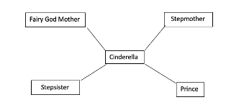

Another great way to provide students with an engaging activity is with a news report segment. In this activity the teacher will act as a news reporter and students can volunteer to respond to a question from the character of their choice.

Teacher: It’s the morning news and I’m here with Mother Gothel, mother of Rapunzel who has gone missing. Mother Gothel can you tell us why Rapunzel was in the tower in the first place?
Students: Well I put her in the tower because when she was a little girl a man and his wife tried to kidnap her from me claiming I was a witch and she was theirs which is not true!

Teacher: Hi it’s time for the 5 o’clock news! We’re here talking to the giant who says a young boy named Jack has stolen his precious harp and hen that lays golden eggs. Can you tell me a bit more about what happened to make you so tired the day he stole your stuff?
Student: I had a long day! I was busy visiting my sister because she just had a new baby, but she lives on a different beanstalk. It took me hours to walk there and back so I thought I’d just have a quick nap and that’s when he came! He took everything even though I never did anything wrong to him. If he asked, I would have given him one of the eggs.

Model: This is a period where the teacher can show a short piece written at the level the students will be expected to write at. Within the story the students work together to identify the new character perspective, the misunderstanding, and key plot points that the piece has included. This is also the time for the teacher to introduce the writing strategies for rewriting the story in a new perspective. Writers should first choose a story and character perspective to write from. From there they can outline the key plot points of the story and highlight an area for possible misunderstanding. They can then begin to rewrite the story outline following the new perspective. From there they work to write a final draft. Here is an example of teacher text:

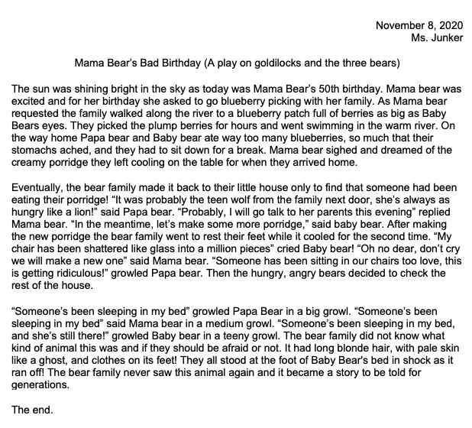
Shared/Guided Writing: Using one of the characters and stories written on the board, the teacher will help the class write a complete outline of a story. First, they will write the plot points of the chosen fairy take. Next students will work together to show an area where a character’s actions were misunderstood. From there they will go through each plot point of the story and rewrite it. See example below:

The three little pigs from the wolf's perspective – the wolf just wanted some friends
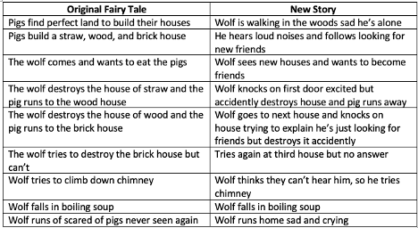

Independent writing: Students will now create their own stories. Provide students with a planning sheet to work through their ideas and outline their stories. The writing should be 1 to 2 pages and be writing in their writing journals.

Reflection: Once the class has finished their stories the teacher should conduct a reflection discussion asking students questions on their experiences changing a stories perspective.
Example questions:
Was it easy or difficult rewriting a story from a different perspective?
Did you find your story changed dramatically?
What do you think about considering different perspectives in stories other than fairy tales?

Lesson 3: Using Similes to Describe

Connection to Curriculum:
Big Ideas “Developing our understanding of how language works allows us to use it purposefully”
Elaboration “Written texts include novels, articles, and short stories.”

Curricular Competency “Understand how literary elements, techniques, and devices enhance and shape meaning”
Elaboration “literary elements, techniques, and devices: may include characterization, mood, foreshadowing, conflict, protagonist/antagonist, theme, imagery, sound devices”

Content “Literary elements”
Elaboration “literary elements: narrative structures, characterization, and setting”

Context: This lesson is for a grade 6 class and relies on previous writing for students to improve from lessons 1 and 2.

Materials: Writing from previous lessons. Paper copy of Mama Bear’s Bad Birthday. Fairy tales read in the unit (such as Snow-white, Cinderella, and Rapunzel).

Assessment Methodology: improvements and edits made on previous writing

Hook: Read through quotes with the class containing descriptions of characters from traditional fairy tales read during the unit. Through guided questions show students how the author uses similes to paint a clear picture of what the characters looked or acted like.
Example quotes:
“Soon afterward she had a little daughter who was as white as snow, as red as blood, and as black as ebony wood, and therefore they called her Little Snow-White” – snow white
“Rapunzel had splendid long hair, as fine as spun gold” - Rapunzel
*used to describe setting*
“winter came the snow spread a white cloth” – Cinderella

Purpose: When reading a story without pictures we can still create images of what’s going on in our minds. The author still paints a picture for readers to see but they don’t always use art, they use words as well. Although students are working with well-known stories it is still important to provide readers with powerful descriptions. One great way they can do this is with similes!

Brainstorm: For this brainstorming session students will be playing a game called The Simile Showdown. Begin by dividing the class into 3 equal teams and provide them with a pencil and paper to write with. The teacher begins by writing a noun and adjective on the board. Teams then have one minute to write down as many similes as they can. The teams read aloud and count up their similes. The team with the most similes gets a point. This can be played for a few rounds.
Students can use the prompt “a (noun) as (adjective) as (simile)”
Examples
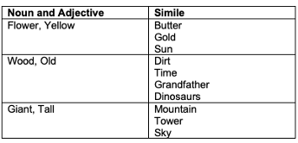

Model: To determine whether students grasp the concept return to Mama Bear’s Bad Birthday and ask the class to highlight places where similes are used to describe.
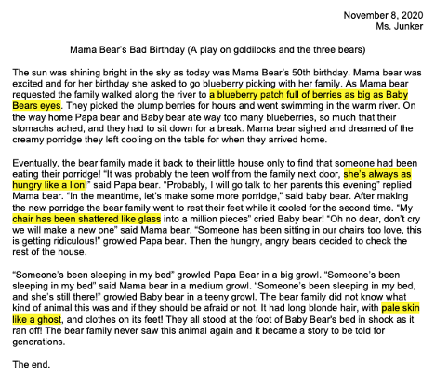
Shared/Guided Writing: Still using mama bears bad birthday, ask students to work in pairs to highlight 3 areas where a simile could have been used. Once they have found an area, ask them to rewrite the sentence with a creative simile (see italics).
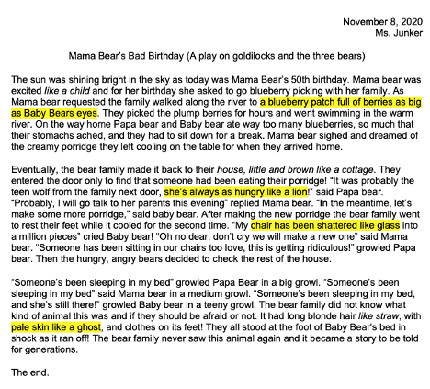
Independent Writing: Students can now return to their individual work and find areas they can include at least 2 similes to describe. Once complete students can exchange writing with partners to check work.

Reflection: In pairs ask the students to reflect on the effectiveness of using similes to describe things in their stories, what were some difficulties they had, and how they can use this in other writing pieces.

References
BC’s New Curriculum. Retrieved October 10, 2020. English Language Arts. https://curriculum.gov.bc.ca/curriculum/english-language-arts/6
Beginning, Middle, and End Anchor Chart. (n.d.). Retrieved November 09, 2020, from https://www.teacherspayteachers.com/Product/Beginning-Middle-and-End-Anchor-Chart-1923062
Grimm, J. & Grimm, W. (n.d.). Grimm 021: Cinderella. University of Pittsburgh. https://www.pitt.edu/~dash/grimm021.html

Grimm, J. & Grimm, W. (n.d.). Grimm 012: Rapunzel. University of Pittsburgh. https://www.pitt.edu/~dash/grimm012.html

Grimm, J. & Grimm, W. (n.d.). Grimm 053: Little Snow-White. University of Pittsburgh. https://www.pitt.edu/~dash/grimm053.html
Purdue Writing Lab. (n.d.). On Paragraphs. Retrieved November 09, 2020, from https://owl.purdue.edu/owl/general_writing/academic_writing/paragraphs_and_paragraphing/index.html

